**Private Party Menu**

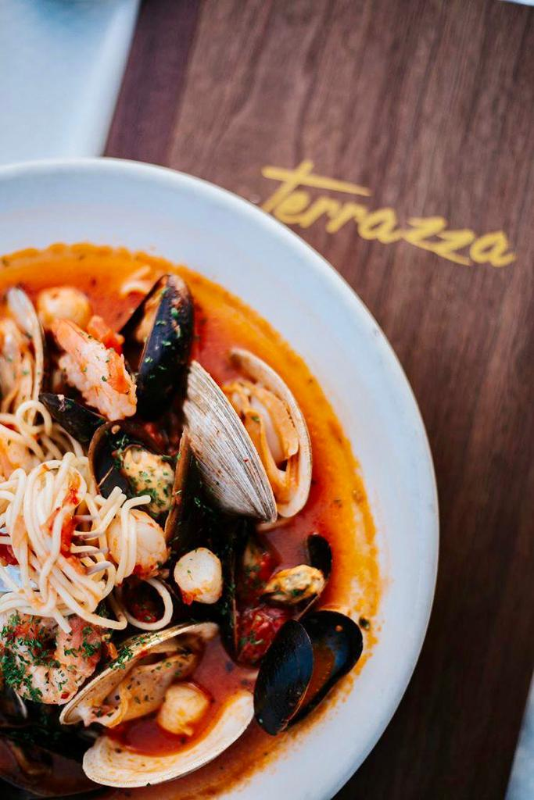 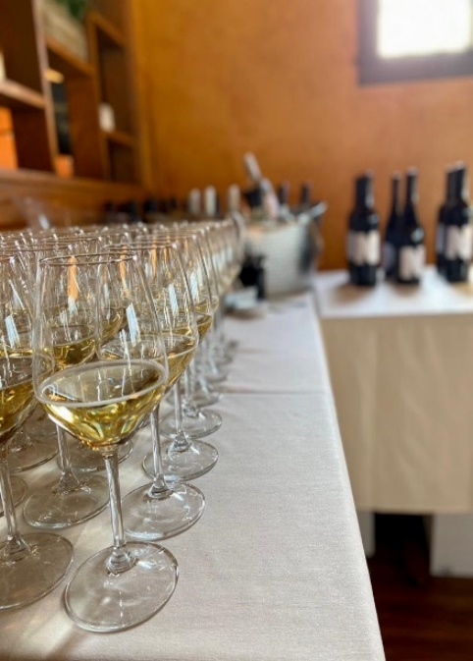

645 DOUGLAS PIKE, SMITHFIELD RI 401.233.3223 ext:2 INFO@TERRAZZARI.COM

Megan Lasher GM l Event Coordinator

[Megan.lasher@terrazzari.com](mailto:Megan.lasher@terrazzari.com)

Text 802.745.7383

 

**Hors d’ Oeuvres**

*Priced per person*

**Hummus $2.50pp**

Chickpeas, tahini, Meyer lemon, & olive oil,

served with pita bread

**Add pine nuts $1 | Add side veggies $1**

**Crab Cakes $5pp**

Jumbo lump crab meat, panko breadcrumbs, herbs & spices deep fried with chipotle aioli

**Terrazza Shrimp $6pp**

Toasted garlic, jalapeños, Meyer lemon &

lobster butter

**Add garlic crostini $1pp**

**Calamari $4pp**

Lightly floured calamari tossed with cherry peppers, citrus & cherry pepper aioli

**Crispy Brussel Sprouts $2.50pp**

Extra crispy Brussel sprouts, tossed with crispy bacon bits & a maple sriracha glaze

**Mediterranean Egg Rolls $4.50pp**

Chicken, spinach, mozzarella, and feta cheese wrapped in dough, fried & served with jalapeño-cilantro sauce

**Margherita Flatbread $16**

*(16 party slices)*

Light tomato sauce, fresh sliced mozzarella, grated parmesan & fresh basil

*Make gluten free $3*

**Fig Jam and Prosciutto Flatbread $19**

*(16 party slices)*

Parma prosciutto, fig jam, arugula, shaved pecorino Romano, Ricotta & mozzarella cheese

*Make gluten free $3*

**Buffalo Chicken Flatbread $20**

*(16 party slices)*

Red hot sauce, mozzarella cheese, Buffalo fried chicken, celery leaves and a blue cheese drizzle

*Make gluten free $*

**Colossal Shrimp Cocktail *Market\***

Served Over a Bed of Ice, Cocktail Sauce, & Lemons

**International & Domestic Cheese and Crackers $3pp**

Chef’s assorted cheeses and crackers

**Add chef selections of cured meats $1.50**

**Mussels $3.50pp**

*Choice of diablo or bianco*

Sautéed in white wine, garlic and onion

**Empanadas $3pp**

*Choice of chicken or beef*

Served with house made BBQ aioli

**Meatballs $3pp**

Served in a house made pomodoro sauce

**Finger Sandwiches & Sliders $4.50pp**

Short rib, meatball, chicken salad, cheeseburger and chicken finger



**Greens**

*$3 pp*

**Fattoush**

Romaine hearts, arugula, tomatoes, red onions, cucumbers & pita chips,

served with a sumac vinaigrette

**Caesar**

Crisp Romaine, creamy Caesar dressing, house made pita chips & Parmesan

**Arugula**

Baby arugula & shaved parmesan, served with a Meyer lemon & garlic vinaigrette.

**Caprese Display +$.50**

Tomatoes and Mozzarella Cheese Layered with Fresh Basil & Topped with a Balsamic Glaze, EVOO, salt & pepper

**Pasta**

**Seafood $11pp**

Shrimp, scallops, mussels, calamari & pasta tossed in your choice of creamy lobster parmesan sauce or spicy diablo

**Carbonara $5pp**

Bacon, mushrooms & peas in a parmesan cream sauce tossed with penne, finished with parmesan

**Add Chicken $4 l Shrimp $6**

**Penne $4**

Choice of: alfredo, pink vodka, or Pomodoro

**Bolognese $6pp**

Beef, pork and veal slowly cooked with celery, carrots, tomatoes and cream

**Protein**

**Marsala $8pp**

Lightly floured chicken in a mushroom Marsala wine reduction

**Piccata $8pp**

Lightly floured chicken tossed with grape tomatoes, artichokes & capers in a white wine, lemon butter sauce

**Pink Vodka Parmigiana $9pp**

Panko & Parmesan crusted chicken breasts, pink vodka sauce, melted mozzarella & parmesan cheese

**Sesame Crusted Salmon $9pp**

Pan seared fresh salmon fillet crusted with sesame seeds

**Mixed Grill $10pp**

Skewers of grilled chicken & steak, marinaded in Mediterranean spices

**Filet Mignon *MARKET\***

Center cut Certified Angus beef tenderloin, chargrilled, & topped with garlic herb butter

**Prime Rib *MARKET\***

Slow roasted prime rib of beef served medium rare in au jus

**Pork Tenderloin $8pp**

Maple balsamic marinated, pan seared, served sliced with sauteed granny smith apples

* All beef pricing is subject to a surcharge based on the current market conditions, please consult your event specialist for current pricing



**Sides**

Rice Pilaf $3pp

Red Bliss Mashed potatoes $3pp

French Fries $2.50pp

Risotto $4pp

Garlic Spinach $3pp

Roasted Potatoes $3pp

Vegetable Medley $3pp

Grilled Asparagus $3pp

**Corporate**

**LUNCHEON**

**\*\***PLEASE INQUIRE ABOUT SPECIAL LUNCHEONS AND ITEMS NOT LISTED

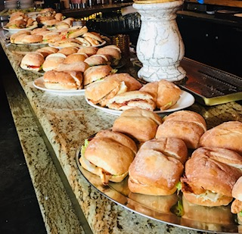 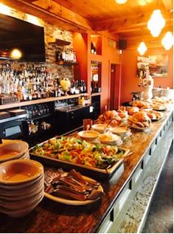

**Brunch**

Fluffy Scrambled Eggs $3pp

Eggs Benedict $5pp

Veggie Mediterranean Scramble $4

Cinnamon sugar French Toast $3pp

*add fresh berries $1pp*

Stuffed French Toast Bread Pudding $4pp

*(mixed berries & mascarpone cheese or Chocolate chip)*

Bacon $4pp

Sausage $4pp

Honey Glazed Ham $4pp

Home fries $3pp

Hashbrowns $3pp

Assorted Breakfast pastries & muffins $3.50pp

Fruit Platter $3.50pp

Yogurt w/ granola cups $3pp

Mixed berries, granola & Yogurt cups $3.50

Breakfast pizza $19

*Scrambled egg base, mozzarella, feta, onions, tomato, spinach, bacon & sausage. Finished with a siracha maple drizzle.*

Unlimited Juice $2.50pp

Coffee Station $40 regular/$40 decaf

Unlimited Soda $2.50pp

Sangria Pitcher $40/pitcher

*(red, white, or champagne)*

Mimosa Bar $40/bottle (save $4per bottle if adding unlimited juice)

*(comes with OJ, Pineapple, Cranberry & Grapefruit Juice)*

**

**Kids Corner**

*(3-12yrs old: $8per child)*

**Pizza (cheese or pepperoni)**

**Mac & cheese**

**Chicken fingers**

**French fries**

**Pasta (butter or marinara)**

**Dessert**

We allow our guests to bring cakes or desserts made from a bakery or store. Absolutely no homemade food or desserts are allowed in the restaurant per the health department.

***Terrazza highly recommends Ivy & lace bakery, Who Cut The Cheese Cake and Have Your Cake. They can be found on facebook, Instagram and google***

**Bar**

You’re welcome to customize your bar to best fit your special day:

Cash bar

Full open bar

Limited open bar

Just beer and/or wine

Mimosa bar

Sangria bar

**Table clothes & Napkins**

* Colors must be made 2 weeks in advance
* Table clothes $40
* Napkins
* We provide a cake table, gift table, buffet table etc. at no additional charge

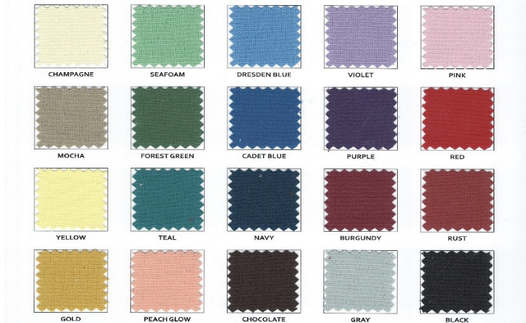

**Event types & times**

**Events such as: Baby showers, Bridal showers, 1st communions, confirmations, baptisms are held- Saturdays or Sundays between the hours of 11am-3pm**

* All daytime parties must meet a $1200 minimum on food and beverages. Taxes, gratuity, any fees, etc. are in addition to the minimum.

**Casual after-work gatherings 15-25 people: can be held around our indoor or outdoor bar with a few tables. They may be held between the hours of 3-6pm Sunday-Thursday and 3-5pm Friday and Saturdays**

* must meet a $400 minimum on food solely. Beverages, taxes, gratuity, etc. are in addition to the minimum

**Private patio lounge: weather dependent and offers couches and a table. Can accommodate up to 30 people.**

* must meet a $800 minimum on food and beverages. Taxes, gratuity, etc. are in addition to the minimum
* This is a more casual atmosphere and best for appetizers and pizza and not sit-down dinner

*Patio is weather dependent and can only be reserved during certain days and hours. Patio cannot be guaranteed and Terrazza has the rights to move the function inside at any time.*

**Functions outside of these dates and times must be discussed with management and are dependent upon dates, times, minimums & availability**

*YOU MAY RENT OUT THE RESTAURANT TO BE SOLELY PRIVATE DURING BUSINESS HOURS: DATES AND TIMES MUST BE APPROVED BY THE GENERAL MANAGER – SPENDING MINIMUMS RANGE BETWEEN $7,000-$10,000 AND WILL BE SCALE BASED UPON DATES CHOSEN*

**Wedding receptions:** To rent out Terrazza for a wedding reception there will be a $500 rental fee in addition to minimums met depending on dates and times.

**Deposits & Contracts**

All events and parties are required to make a $200 nonrefundable security deposit to hold the reservation via major credit card or check. Your $200 security deposit will be deducted from your final bill.

* Final head counts must be made 1 week prior to date of event
* Any final food or linen changes must be made 2 weeks prior to date of event

**Menu Pricing**

Terrazza has the rights to change menu pricing at any time. You are responsible to pay the menu price that is agreed upon in contract.

* Children between the ages of 0-2 are free. Children are welcome to have their own individual meals, or we can have a kids buffet, or they can eat from the regular buffet.
* Children’s meals do have to be discussed ahead of time
* Please add an additional 8% tax, 20% gratuity

**Decorations**

We allow you to bring your own decorations. Guests can drop off decorations the night before for us to decorate or you’re welcome to arrive up to 1 hour prior to event to decorate yourselves. We ask that only a few people (up to 4 people) are early to help set up as it can prevent our staff from properly setting up and completing their duties.

* Flying confetti cannot be used: there will be a $100 cleaning fee if used
* Sprinkled confetti on the table can be used- there is an additional $50 cleaning fee if used
* Balloons must be taken and not left- there is an additional $50 cleaning fee if left

**Staffing**

Each event is properly staffed per head count, men provided and complexity of event.

* Passed hors D’oeuvres - require more staff and an additional $50 per staff working the event.
* Carving station- $50 additional gratuity to carving chef

**Rooms**

* We have a four seasons room with private bar that most parties will be held in. It can accommodate up to 33 guests sitting down more formal or 60 guests more casual standing, mingling with some tables.
* A indoor dining room with fire place, this room can accommodate up to 50-55 guests sitting more formal or 80 guests more casual standing and mingling with tables. This room may be subject to higher spending minimums depending on the date and time. Also has a private bar.
* Both rooms can be used and are joined by large double doors for larger parties and events. Max capacity for formal sit down dinner is 80-105 or 140 more casual standing mingling with some tables and both bars.
* The patio (weather dependent) can also accommodate 100-140 guests. With 1-2 private bars and lounge

COME CELEBRATE WITH US AND LET US DO THE COOKING!

